



**Easy Animated Cursors**

*Change cursors easily, animate them, design*

**Documentation**

**by cartridgegamestudio**

**What is this?**

This is simple script for integrating your animated sprites as cursor. You can also use non-animated sprites as well.

Code itself comes with tiny code-library. So, you can call some functions from outside to make your cursors more dynamic.

Check Demo scene for better understanding. Demo scene also have OnHover implementations, Glow Lerp implementations and Sprite Animation that can come handy for quick tests.

This package supports both Mobile and Desktop development.

**Usage of Scripts**

Usage of scripts is quite easy. I will explain them step-by-step. So, have no worries.

All you need to do drag-drop CursorManager.cs script to any object you like. Rest will be customized from Editor window. Therefore, let’s explain fields and their purpose one by one.

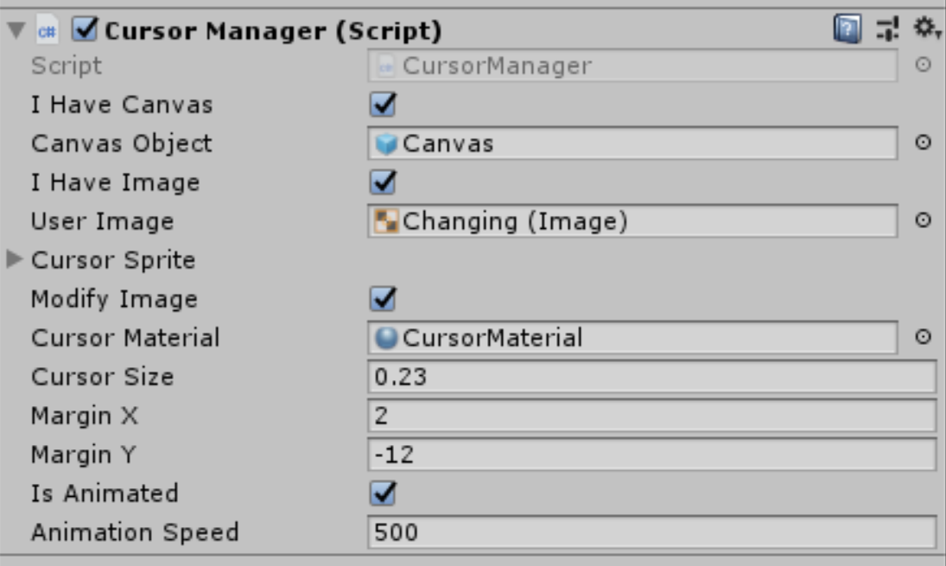**I Have Canvas:** This is for telling script whether you have canvas object or not. If you don’t, it will automatically create one for you. If you have one but still uncheck this, then your scene will have 2 Canvases which is a problem.

**Canvas Object:** This will be available only if you say I Have Canvas. You need to drop your Canvas object to there.

**I Have Image:** We are using images as cursor on the canvas. So, if you have a customized image with scripts attached to that (Check Demo) then you should select this.

**User Image:** If you selected “*I have Image”* option, you should also drag your Image GameObject to User Image field.

**Cursor Sprite:** Cursor Sprite Array is the array that will contain your Cursor Sprites. Even if you don’t want to use animated scripts, you should still add single Sprite to this array.

**Modify Image:** If you select this option, our script will be able to modify your Image’s size and material from Editor panel.

**Margin X – Y:** This option for adjusting the margin of X-Y Coordinates. Some Cursors might have different sizes and shapes. You need to manually set this to make it perfectly fit with the image.

**Is Animated and Animation Speed:** When you click Is Animated, Animation Speed field will pop. Animation is simply iterating over Sprite Array based on the speed variable

**Tiny Script Library**

You can call these public methods to manipulate your cursor on runtime.

bool SetCursor(Sprite[] newSpriteArr) //Change cursor on runtime with Sprite Array

bool SetCursor(Sprite newSpriteArr) // Change cursor on runtime with single Sprite

* This will stop any running animation because single sprite is violation of animation logic.

void SetCursorSize(float newCursorSize) // Change cursor size on runtime

* This will also modify image’s width and height.

void SetAnimationSpeed(float newAnimSpeed) // Set Animation speed on runtime.

* This will automatically start animation. No need to call Start afterwards.

void SetCursorMaterial(Material newMaterial) // Changes cursor material on runtime.

void StartAnimation() //Start Animation.

* This will modify IsAnimated property automatically.

void StopAnimation()

* This will set IsAnimated property to false automatically.

**! Notes !**

Feel free to use any Demo Scripts inside the Demo Scripts folder for any purpose.

I don’t recommend anyone to use Demo Sprites for Commercial purpose. Because they are coming inside the asset, they can be used by anyone which will result a bad quality for your Game/Software having a shared identical property with other Game/Software in the market.

**Credits**

*Fonts from - https://www.1001fonts.com/fifteen-okay-font.html*

*Heartbeat inspired and redesigned for Unity Sprites from - hSttps://dribbble.com/shots/3425402-Heartbeat-loader-animation*

*Sword Cursor inspired and redesigned for Unity Sprites from - http://www.rw-designer.com/cursor-detail/11923*

*Wave Circles inspired and redesigned for Unity Sprites from this amazing code - https://codepen.io/pshkvsky/pen/ojxGBL*

*Flashback inspired and redesigned for Unity Sprites from - http://30000fps.com/post/168089970358*

**Contact**

If you have any questions – requests or bug reports, you can contact to me from [cartridgegamestudio@gmail.com](mailto:cartridgegamestudio@gmail.com) whenever you want. I usually check my emails so I probably will give an answer as soon as possible.